**PROJECT REPORT**

* **INTRODUCTION OF 3DMAX:**

3D Max  is a professional [3D computer graphics program](https://en.wikipedia.org/wiki/3D_computer_graphics_software) for making 3D animations, models, games and images. It is developed and produced by [Autodesk Media and Entertainment](https://en.wikipedia.org/wiki/Autodesk_Media_and_Entertainment).[[1]](https://en.wikipedia.org/wiki/Autodesk_3ds_Max#cite_note-1) It has modeling capabilities and a flexible [plug-in](https://en.wikipedia.org/wiki/Plug-in_(computing)) architecture and can be used on the [Microsoft Windows](https://en.wikipedia.org/wiki/Microsoft_Windows)platform. It is frequently used by [video game developers](https://en.wikipedia.org/wiki/Video_game_developer), many TV commercial studios and architectural visualization studios. It is also used for movie effects and movie pre-visualization. For its modeling and animation tools, the latest version.

* **OBJECTIVE OF PROJECT:**

This project is a small project made by using 3D Max objects and modifiers. The whole scene in this project is that of a park in which two fallows are sitting on concrete blocks and having some donuts, the animation incorporated is the shifting of donuts from the plate in to the individual person's plate.

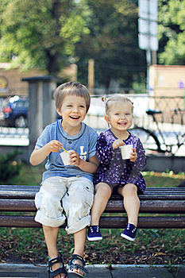The idea of this project is taken from the below image of two kids which represents the strength of love and sharing.



* **FEATURES:**

The two key features in this project are:

**1.**Modeling

**2.**Animation

* **COMPONENTS:**

There are two constituents of the project:

1.Objects

2.Modifications

* **OBJECTS:**

Following are the objects used in projects:

**1**.Donut:

Donut object is a combination of two circles, in which one circle has less radius than the other , so that on circle gets inside the other.

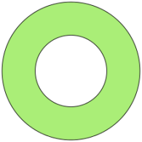

Figure1: Donut Object

**Usage:**

In the project donut object is used to placed on the plate present on the table in front of bipeds.

**2.**Plane:

A plane is a closed rectangular shape surface with four sides.

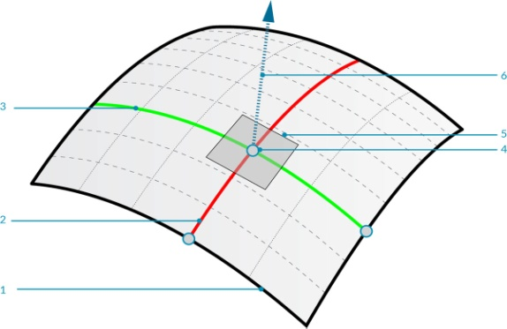

Figure 2: Plane Object

**Usage:**

In the project plane object is used to as a ground for the placement of other objects.

**3.**Cylinder:

A cylinder object is a three dimensional shape with two round shapes at either end and two parallel lines connecting the round ends.

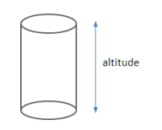

Figure 3: Cylinder object

**Usage:**

In the project cylinder object is used as a plate for donuts and also for the individual biped's plate.

**4.**Box:

A box object is a square shape with three dimensions and volume.

Shape Square Cube Geometry - shape


Figure 4: Box object

**Usage:**

In the project box object is used as a bench for the bipeds and also the table for plate of donuts.

**5.**Biped:

A biped is basically a two footed animal which could be transformed from a skeleton to a human being.

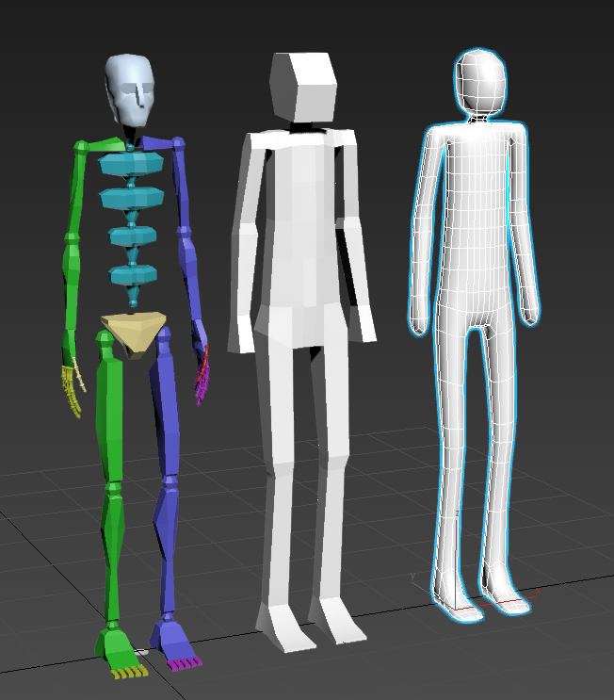

Figure 5: Biped Object

**Usage:**

In the project biped object is used to create two fallows sitting on the bench of park.

**6.**Pyramid:

A pyramid object is a triangle shape with three dimensions.

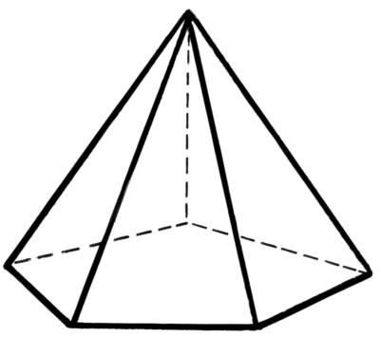

Figure 6: Pyramid Object

**Usage:**

In the project pyramid object is used as a decoration piece for the fence of park.

**7.**Line:

A line is the connection between two points that can be curve or straight.

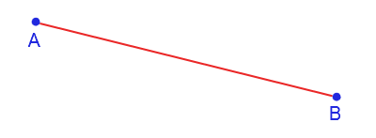

Figure 7: Line Object

**Usage:**

In the project line object is used to create the arch for the entrance of park.

* **MODIFIERS:**

Following are the modifiers used in projects:

**1.**Hair and Fur:

Hair and Fur is the modifier that creates hair shaped bushes on a object on which it is used

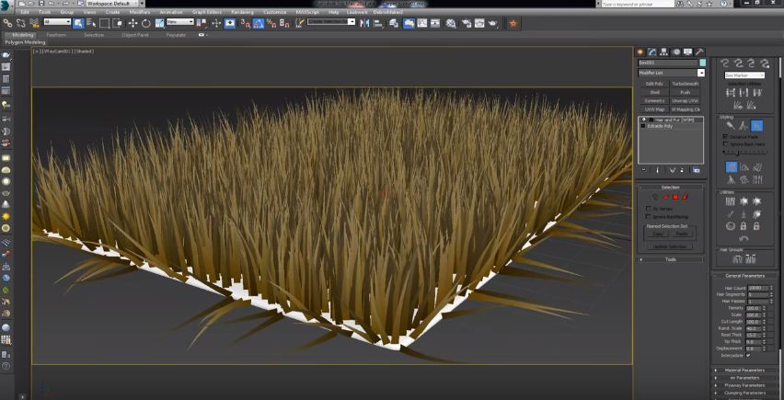

Figure 8: Hair and Fur Object

**Usage:**

In the project Hair and Fur modifier is used to create grass on the plane of model.

**2.**Lattice:

The lattice modifier makes the connecting points of matrix of object more prominent and thick.

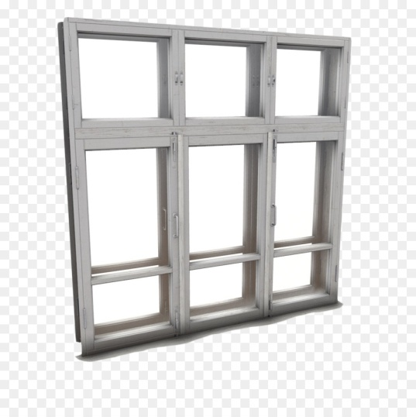

Figure 9: Lattice Modifier

**Usage:**

In the project Lattice modifier is used to create the walls for the park and also to create the arch for the entrance of park.

**3.**Melt:

Melt modifier makes an object reshaped in to another required shape.

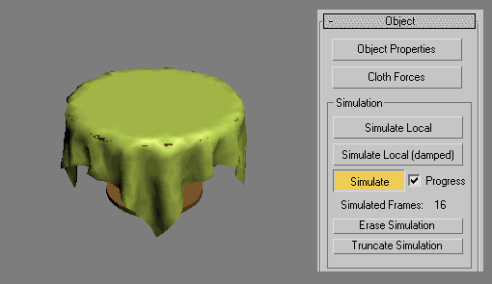

Figure 10: Melt Modifier

**Usage:**

In the project Melt modifier is used to reshape the cylinder in form of plate for donuts.

**4.**Bevel:

A bevel is the modifier that makes the slopes of any object more prominent and thick.

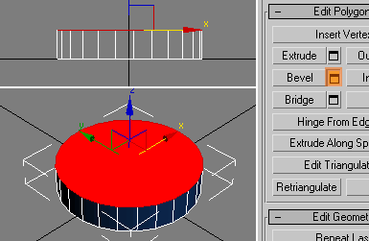

Figure 11: Bevel Modifier

**Usage:**

In the project Bevel modifier is used to modify the donut object so that realistic donuts could be seen.

* **FINAL OUTPUT:**

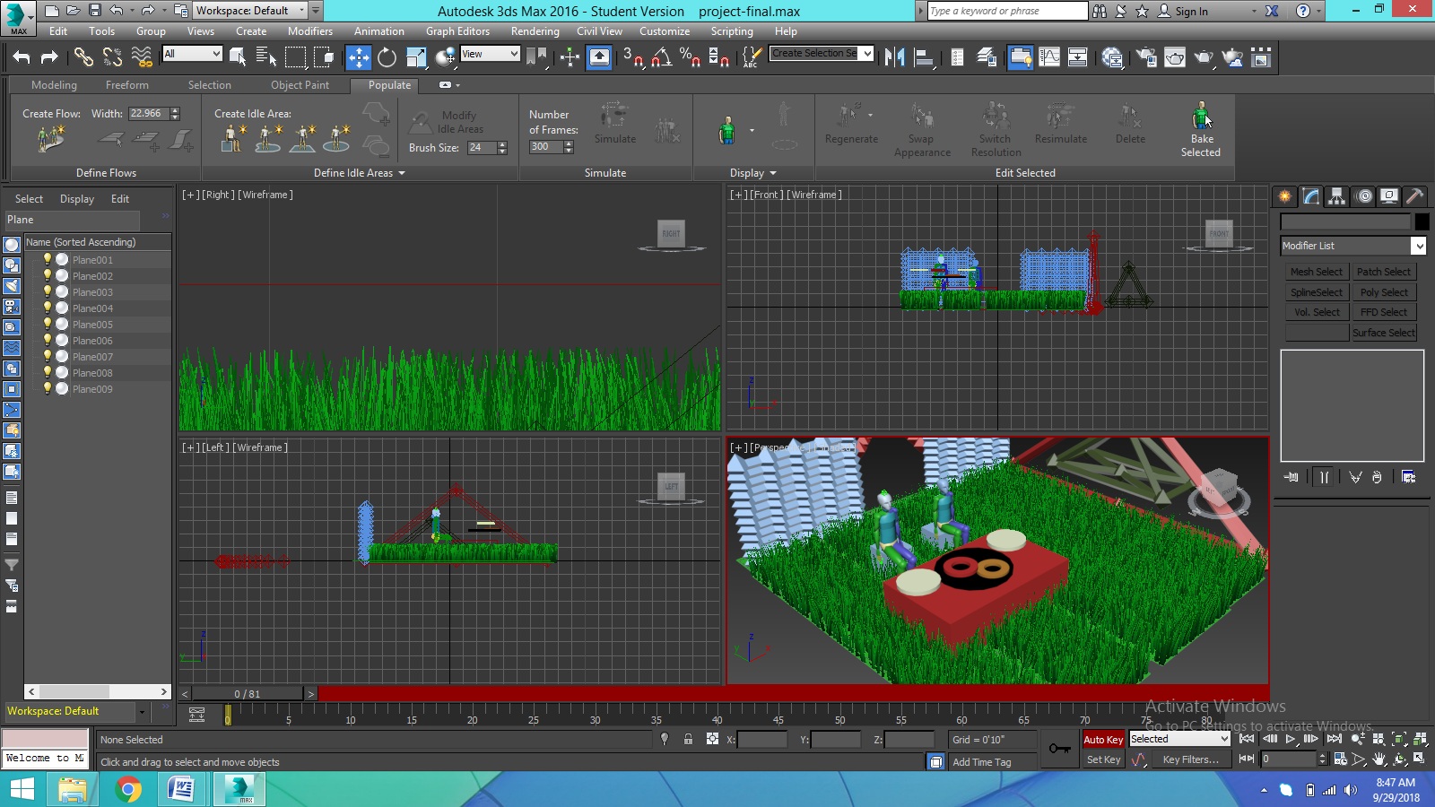

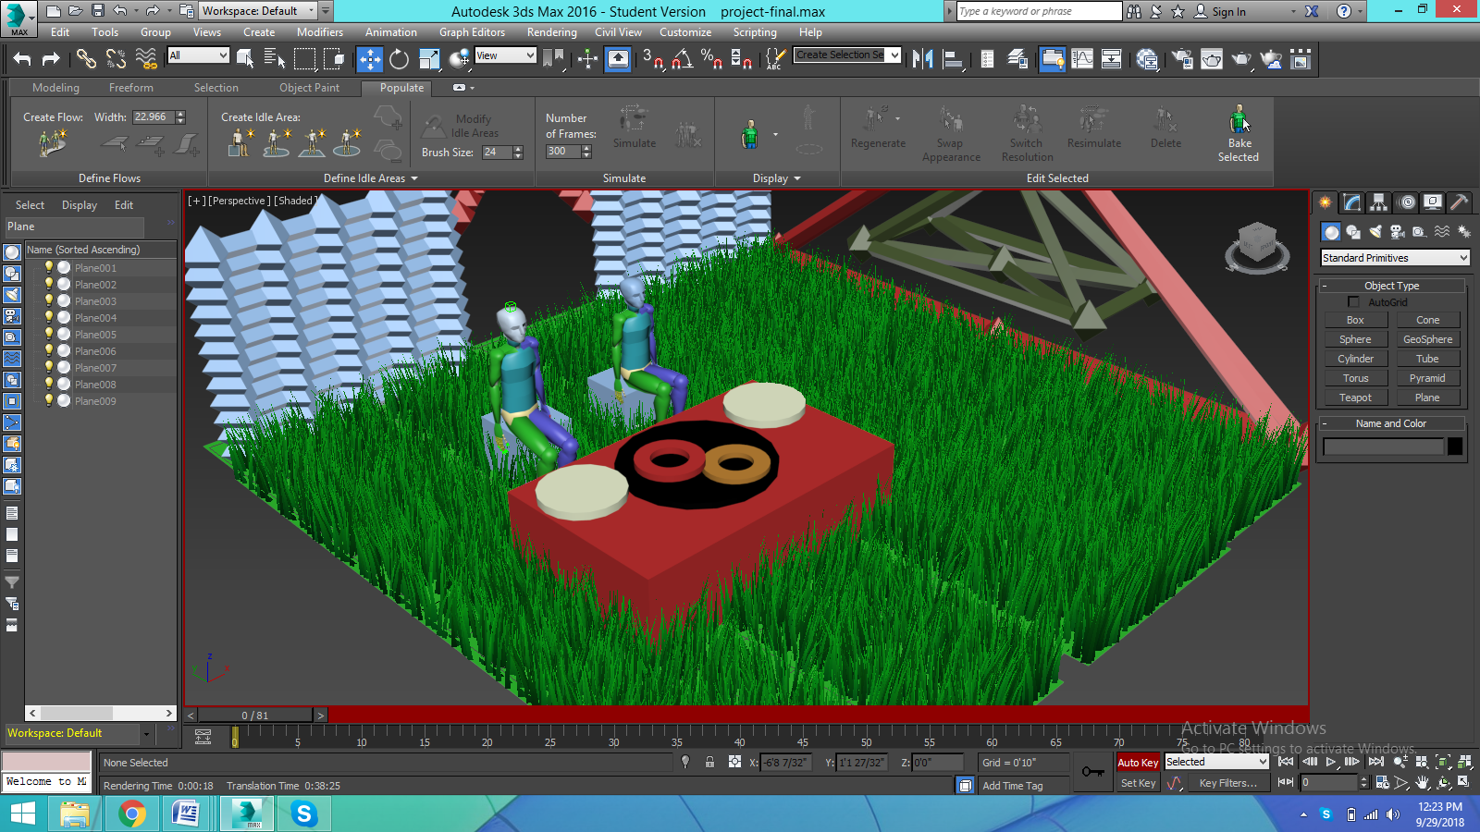

* **REFERENCE:**

The helping hands were:

<https://es.dreamstime.com/>

<https://png-library.com/>

<http://www.republicofcode.com/>

<https://www.youtube.com/>